Assignment 10: Analysis Report

# Histogram

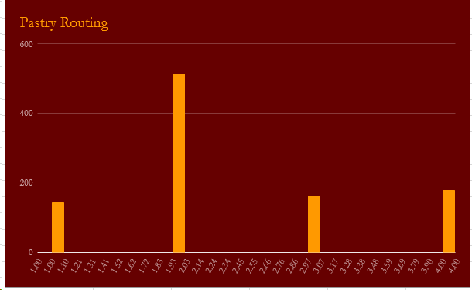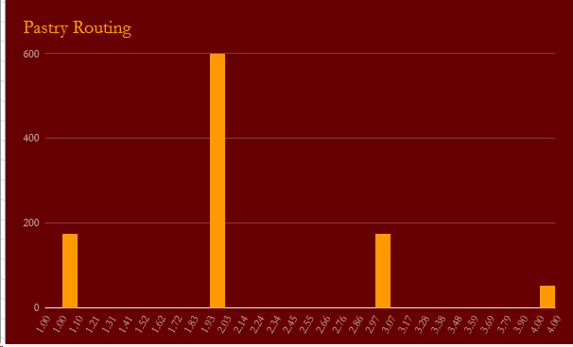

## Data

### Trial 1

|  |  |
| --- | --- |
| Hops | Count |
| 1 | 145 |
| 2 | 514 |
| 3 | 162 |
| 4 | 179 |

### Trial 2

|  |  |
| --- | --- |
| Hops | Count |
| 1 | 174 |
| 2 | 599 |
| 3 | 175 |
| 4 | 52 |

# Analysis

The pastry routing tends to find the ID or at least a null IP by the second hop.